**SYDNEY WESTERN CITY PLANNING PANEL ASSESSMENT REPORT**

|  |  |
| --- | --- |
| Panel Number: | PPSSWC-366. |
| Application Number: | 2023/521/1. |
| Local Government Area: | Camden Council. |
| Development: | Construction of a centre-based child care facility for up to 197 children aged 0 to 5 years, with car parking, drainage, retaining walls, landscaping, signage and associated site works. |
| Capital Investment Value: | $8,526,983. |
| Site Address(es): | 9 Gregory Hills Drive, Gledswood Hills. |
| Applicant: | Damian O’Toole Town Planning Pty Ltd. |
| Owner(s): | Soma Precinct Pty Ltd. |
| Date of Lodgement: | 15 September 2023. |
| Number of Submissions: | None. |
| Number of Unique Objections: | None. |
| Classification: | Regionally significant development. |
| Recommendation: | Approve with conditions. |
| Regionally Significant Development Criteria (Schedule 6 of State Environmental Planning Policy (Planning Systems) 2021): | Private infrastructure and community facility (child care centre) with a capital investment value >$5 million. |
| List of All Relevant Section 4.15(1)(a) Matters: | * State Environmental Planning Policy (Planning Systems) 2021. * State Environmental Planning Policy (Precincts - Western Parkland City) 2021. * State Environmental Planning Policy (Transport and Infrastructure) 2021. * State Environmental Planning Policy (Industry and Employment) 2021. * State Environmental Planning Policy (Resilience and Hazards) 2021. * State Environmental Planning Policy (Biodiversity and Conservation) 2021. * State Environmental Planning Policy (Sustainable Buildings) 2021. * Turner Road Development Control Plan 2007. * Camden Development Control Plan 2019. |
| List all Documents Submitted with this Report for the Panel’s Consideration: | * Assessment report. * State Environmental Planning Policies (SEPP) assessment tables. * Development Control Plans (DCP) assessment tables. * NSW Child Care Planning Guideline assessment table. * Proposed plans. * Recommended conditions. |
| Development Standard Contravention Request(s): | None. |
| Summary of Key Submission Issues: | None. |
| Report Prepared By: | Annabelle Jones, Executive Planner. |
| Report Date: | April 2024. |

**Summary of Section 4.15 Matters**

|  |  |
| --- | --- |
|  | **Yes** |
| Have all recommendations in relation to relevant Section 4.15 matters been summarised in the Executive Summary of the assessment report? |  |

**Legislative Sections Requiring Consent Authority Satisfaction**

|  |  |
| --- | --- |
|  | **Yes** |
| Have relevant sections in all applicable environmental planning instruments where the consent authority must be satisfied about a particular matter been listed and relevant recommendations summarised in the Executive Summary of the assessment report? |  |

**Development Standard Contraventions**

|  |  |  |
| --- | --- | --- |
|  | **Yes** | **N/A** |
| If a written request for a contravention to a development standard has been received, has it been attached to the assessment report? |  |  |

**Special Infrastructure Contributions**

|  |  |  |
| --- | --- | --- |
|  | **Yes** | **No** |
| Does the application require Special Infrastructure Contributions? |  |  |

**Conditions**

|  |  |
| --- | --- |
|  | **Yes** |
| Have draft conditions been provided to the applicant for comment? |  |

Purpose of Report

The purpose of this report is to seek the Sydney Western City Planning Panel’s (the Panel’s) determination of a development application (DA) for a centre-based child care facility at 9 Gregory Hills Drive, Gledswood Hills.

The Panel is the consent authority for this DA as the capital investment value (CIV) of the development is $8,526,983. This exceeds the CIV threshold of $5 million for Council to determine the DA pursuant to Schedule 7 of State Environmental Planning Policy (Planning Systems) 2021.

Summary of Recommendation

That the Panel determine DA/2023/521/1 for a centre-based child care facility pursuant to Section 4.16 of the *Environmental Planning and Assessment Act 1979* by granting consent subject to the conditions attached to this report.

Executive Summary

Council is in receipt of a DA for centre-based child care facility at 9 Gregory Hills Drive, Gledswood Hills.

The DA has been assessed against the *Environmental Planning and Assessment Act 1979*, the *Environmental Planning and Assessment Regulation 2021*, relevant environmental planning instruments, development control plans and policies.

A summary of the assessment of all relevant environmental planning instruments is provided below with a detailed assessment provided later in the report.

|  |  |
| --- | --- |
| State Environmental Planning Policy (Planning Systems) 2021. | The Panel is the consent authority for this DA as the development has a CIV of $8,526,983. The CIV threshold for Council to determine the DA is $5 million. |
| State Environmental Planning Policy (Precincts - Western Parkland City) 2021. | The development is permitted with consent in the applicable B5 Business Development zone, is consistent with the zones’ objectives and acceptable in terms of the Western Parkland City SEPP’s other matters for consideration. |
| State Environmental Planning Policy (Transport and Infrastructure) 2021. | The DA was referred to Endeavour Energy and Transport for NSW for comment pursuant to the Transport and Infrastructure SEPP and the comments received have been considered. |
| State Environmental Planning Policy (Industry and Employment) 2021. | Council staff are satisfied that the signage is consistent with the Industry and Employment SEPP’s objectives in that it is compatible with the desired amenity and visual character of the area, will provide effective communication by displaying the development’s name and will be of a high quality design and finish. Council staff have also considered the Industry and Employment SEPP’s Schedule 5 assessment criteria and are satisfied that the signage is consistent with it. |
| State Environmental Planning Policy (Resilience and Hazards) 2021. | Council staff have reviewed the submitted phase 2 detailed contamination assessment and are satisfied that the site is suitable for the development. |
| State Environmental Planning Policy (Biodiversity and Conservation) 2021. | The development is considered satisfactory in terms of the matters for consideration in Chapter 6 of the Biodiversity and Conservation SEPP. |
| State Environmental Planning Policy (Sustainable Buildings) 2022. | The development generally complies with the standards for non-residential development with an estimated development cost >$5 million in Chapter 3 of the Sustainable Buildings SEPP. |

The DA was publicly exhibited for a period of 14 days in accordance with Camden Community Participation Plan 2021. The exhibition period was from 16 to 30 October 2023 and no submissions were received.

The site is located in a local business area known as the ‘Soma Wellness Precinct’ containing health specialists, food and drink premises and an existing child care centre. The wider area extending east to the drainage corridor is subject to a concept DA for bulky goods, commercial premises, hotels, a cinema and other child care facilities. The concept approval previously included a mixed use development on the subject site. However, the concept DA was modified on 22 February 2024 to amend the concept for this site to a child care centre, therefore the subject DA poses no inconsistency with the concept approval.

The site is in proximity to an existing four-way signalised intersection between Gregory Hills Drive, Central Hills Drive and Holborn Circuit. As the development proposes left-in entry off Gregory Hills Drive, Council staff raised concerns about queuing and cumulative impacts on the service levels of the intersection during peak periods. The applicant provided further SIDRA modelling which confirms that the proposed development, combined other large developments approved in Holborn Circuit, will maintain service levels ‘C’ from the south and ‘E’ from the north, which are considered satisfactory. Various conditions are recommended to minimise conflicts within the internal access driveway and for waste collections to be outside of peak periods. Subject to these conditions, Council staff do not have any remaining concerns regarding traffic or road safety.

The applicant has also revised the plans to address minor concerns regarding materials and colours, cross flow ventilation and drainage design. The supporting documentation is now capable of complying with all relevant plans, policies and development standards. There is only one minor DCP variation proposed for the maximum display area (m2) for business signage per elevation, which Council staff support based on the context of the site.

Based on the assessment, it is recommended that the DA be approved subject to the conditions attached to this report.

Key Planning Control Variations

There are no variations proposed to any development standards. Refer to the **attached** DCP assessment tables for the minor variations to two of the DCPs signage controls.

Aerial Photo

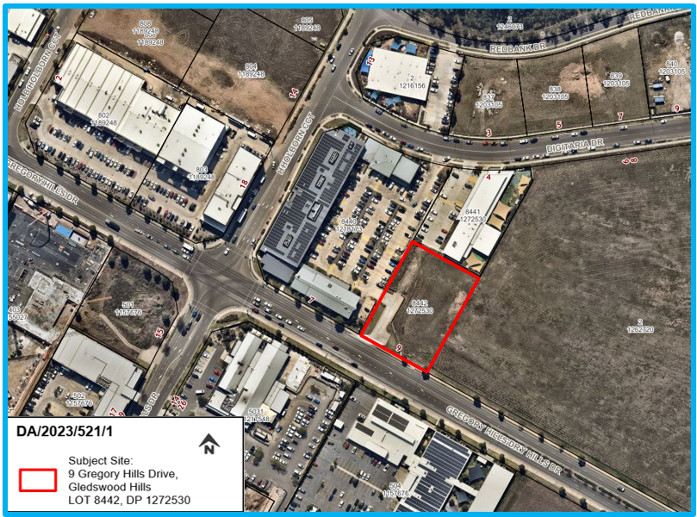

The Site

The site is commonly known as 9 Gregory Hills Drive, Gledswood Hills and is legally described as Lot 8442 in DP 1272530 (outlined in red above). The site is rectangular, has a frontage of 50m to Gregory Hills Drive, a depth of 70m and an area of 3,502m2. Up to 3.7m of cut is required in the north-eastern corner to create an at-grade car park that ties into the adjacent SOMA developments, including an existing child care centre.

The site is not mapped as being flood affected, however the surrounding access roads are partially mapped, based on recent flood modelling undertaken post-subdivision. The site does not contain bush fire prone land and is not in proximity to any heritage items or conservation areas. The site is in the B5 Business Development zone of the Turner Road Precinct in the South West Growth Area.

The surrounding area is characterised by a mix of health services, business and retail premises, food and drink premises and other child care centres. The Gregory Hills Hotel (pub) is located on the opposite corner to the south-west. The site is approximately 500m east of the signalised intersection with Camden Valley Way, a four lane sub-arterial road. The wider area consists of business and industrial land to the south and the residential suburbs of Gregory Hills, Gledswood Hills and Catherine Park to the east, north and west, respectively.

Site photographs

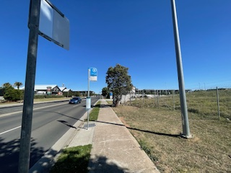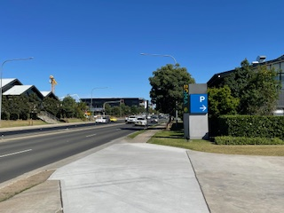

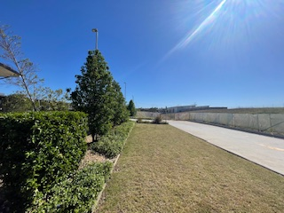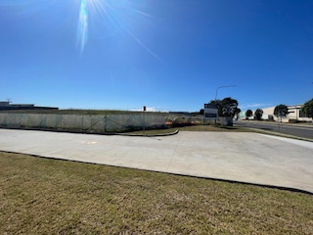

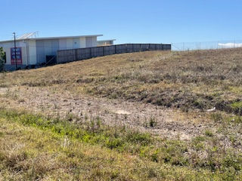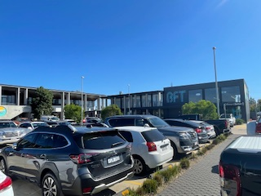

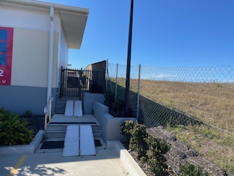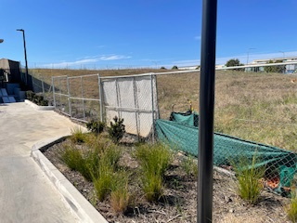

Zoning Plan

**AREA MASTER PLAN**

**HISTORY**

The relevant development history of the site is summarised in the following table:

|  |  |
| --- | --- |
| **Date** | **Development** |
| 18/12/2017 | Concept **DA/2017/45/1** approved by the regional panel for a mixed-use development containing 18 bulky goods premises, 9 business premises, 5 food and drink premises, 6 recreation facilities (indoor), 2 hotels, a cinema, subdivision and associated site works. |
| 01/08/2018 to 22/02/2024 | Various Section 4.55 Modifications to **DA/2017/45/1** to amend the concept scheme and works associated with the approved uses, including the health and child care facilities immediately adjoining the subject site. |

**THE PROPOSAL**

DA/2023/521/1 seeks approval for the construction and use of a centre-based child care facility for up to 197 children.

Specifically, the development involves:

* Construction of a two storey building comprised of concrete block walls clad in white vertical metal with orange vertical feature blades to the upper storey and painted concrete walls with feature signage and screening louvres to the lower storey. The building will have a flat metal roof screened by a 300m high parapet and will contain aluminium window and door frames in a charcoal finish. Feature paint will be applied to the external facades, car park columns and internal pedestrian crossings in a variety of complementary shades (pinks, yellows and greens) that reflect the corporate branding of both the child care operator and the SOMA wellness precinct.
* The ground floor will contain a new car park consisting of 63 car spaces (including two accessible spaces, 4 EV charging spaces, 4 motorcycle spaces and 8 bicycle spaces), an entry lobby, lift and stairs, reception, administration, staff and kitchen areas, two mechanical plant rooms, garbage storeroom and a storeroom for external play equipment.
* The upper floor will contain a lobby, covered and uncovered external play spaces, internal storage rooms and an ‘L’ shaped corridor providing access to 8 play rooms, as per the following:
* Playroom 1: 16 children aged 0 – 2 years;
* Playroom 2: 16 children aged 1.5 – 2 years;
* Playroom 3: 25 children aged 2 – 3 years;
* Playroom 4: 25 children aged 2 – 3 years;
* Playroom 5: 25 children aged 2 – 3 years;
* Playroom 6: 30 children aged 3 – 5 years;
* Playroom 7: 30 children aged 3 – 5 years;
* Playroom 8: 30 children aged 3 – 5 years;
* Ancillary engineering works include earthworks (removal of 4,875m3 of excess cut), extension of water, sewer and electrical services, drainage (including an on-site detention tank beneath the car park), structural retaining walls, construction of a new internal driveway and fire hydrant booster within the front setback.
* Landscaping works include installation of screening garden beds and climbing green walls to the ground floor and embellishment of the upper floor outdoor play space, including six feature shade trees in planters and climbing vines on a perimeter trellis.
* A total of 7 business/building identification signs are proposed, consisting of:
* Sign 1 – Raising Stars sign facing south, 2.1m wide x 2.7m high;
* Signs 2 and 3 – Soma Wellness 3D lettering wrapping around south-eastern corner, 3.7m to 5.45m wide x 800mm high;
* Sign 4 – Smaller SOMA Wellness 3D lettering facing west 5.55m wide x 500mm high;
* Sign 5 – Raising Stars logo/graphic facing west 750mm wide x 1.45m high;
* Sign 6 – Raising Stars logo/graphic facing north 3.8m wide x 2.4m high;
* Sign 7 – Standalone curved/angled low height wall (1.2m high x 5m long) facing entry driveways with SOMA circular graphic 900mm diameter and directional arrows for SOMA centre (left) and child care (right).
* Various vinyl wall graphics and window decals are proposed for the northern, western and southern facades, and internally within the carpark.
* The proposed hours of operation will be 6:30am to 6:00pm, Monday to Friday (excluding public holidays).
* The centre will provide employment for up to 35 staff.

**PANEL BRIEFING**

Council staff briefed the DA to the Panel on 23 October 2023. The following provides an assessment of how the key issues raised by the Panel at the briefing have been addressed:

1. Modification to the Concept Plan DA

*The site forms part of a broader precinct, which is subject to an approved concept Plan DA. Under the concept plan, the site was approved for large format retail development. Given this DA must be consistent with the Concept Plan DA, the Applicant has concurrently sought approval for a modification of the Concept Plan DA. Council is the consent authority for the modification application and plans to determine the application before it sends the DA to the Panel for determination.*

**Officer comment**: The Section 4.55(1A) Modification to the concept DA (reference DA/2017/45/13) was approved by Council on 22 February 2024.

1. Traffic

*Several developments have been approved and built since the Concept DA was approved. Council is seeking updated traffic modelling that incorporates the traffic from these developments. The key issue is the performance of the Gregory Hills Drive/Central Hills Drive intersection and ensuring vehicles can enter and exit the new child care centre during peak periods without adversely affecting the performance of the intersection or causing excessive queuing on Gregory Hills Drive.*

**Officer comment**: Revised traffic modelling submitted by the applicant confirms that the service levels of the intersection will remain satisfactory. The entry driveway that veers to the east for the child care centre can accommodate up to five vehicles, however queuing to this extent is not expected to occur frequently. To further reduce the likelihood of queuing impacts, a condition is recommended which requires the parking spaces closest to the car park entry to be signposted for use by staff only, who are likely to arrive prior to peak periods.

**ASSESSMENT**

***Environmental Planning and Assessment Act 1979 - Section 4.15(1)***

In determining a DA, the consent authority is to take into consideration such of the following matters as are of relevance to the development the subject of the DA:

***(a)(i) the provisions of any environmental planning instrument***

The environmental planning instruments that apply to the development are:

* State Environmental Planning Policy (Planning Systems) 2021.
* State Environmental Planning Policy (Precincts - Western Parkland City) 2021.
* State Environmental Planning Policy (Transport and Infrastructure) 2021.
* State Environmental Planning Policy (Resilience and Hazards) 2021.
* State Environmental Planning Policy (Industry and Employment) 2021.
* State Environmental Planning Policy (Biodiversity and Conservation) 2021.
* State Environmental Planning Policy (Sustainable Buildings) 2022.

State Environmental Planning Policy (Planning Systems) 2021 (Planning Systems SEPP)

The Planning Systems SEPP identifies development that is State significant development, infrastructure and critical infrastructure and regionally significant development.

The Panel is the consent authority for this DA as the CIV of the development is $8,526,983. The CIV threshold for Council to determine the DA is $5 million pursuant to Schedule 6 of the Planning Systems SEPP.

State Environmental Planning Policy (Precincts - Western Parkland City) 2021 (Western Parkland City SEPP)

The Western Parkland City SEPP aims to co-ordinate the release of land for residential, employment and other urban development in the South West Growth Centre.

*Site Zoning*

The site is zoned B5 Business Development pursuant to Appendix 2, Section 2.2 of the Western Parkland City SEPP.

*Development Characterisation*

The development is characterised as a ‘centre-based child care facility’ by the Western Parkland City SEPP.

*Permissibility*

The development is permitted with consent in the B5 zone pursuant to the land use table in Appendix 2 of the Western Parkland City SEPP.

*Planning Controls*

An assessment table in which the development is considered against the Western Parkland City SEPP’s planning controls is provided as an **attachment** to this report.

State Environmental Planning Policy (Transport and Infrastructure) 2021 (Transport and Infrastructure SEPP)

The Transport and Infrastructure SEPP aims to facilitate the effective delivery of infrastructure across the State.

*Referral to Endeavour Energy (Endeavour)*

The DA was referred to Endeavour for comment pursuant to Section 2.48 of the Transport and Infrastructure SEPP. Endeavour raised no objections and confirmed that the electrical demands for the child care centre can likely be met by the existing padmount substation located in Digitaria Drive to the north of the SOMA complex. There are undergound cables within Gregory Hills Drive, however the development is setback 13.472m from the property boundary. Notwithstanding, a condition requiring compliance with Endeavour’s technical guidelines and requirements is recommended.

*Referral to Transport for NSW (TfNSW)*

The DA was referred to TfNSW for comment. Whilst the proposal is not classified as ‘traffic generating development’ pursuant to Schedule 3 of the Transport and Infrastructure SEPP, the site is 500m east of the signalised intersection with Camden Valley Way (classified road), and 75m east of the nearest signalised intersection in Gregory Hills Drive (local road). TfNSW did not raise any concerns regarding traffic impacts on either of these roads. Council staff were advised to ensure that the development provides sufficient on-site parking and access arrangements. The proposal exceeds the minimum parking rate prescribed by the Camden DCP 2019; and the access driveways can comply with Council’s engineering specifications.

An assessment against the SEPP’s child care clauses is provided in the **attached** SEPP tables.

State Environmental Planning Policy (Resilience and Hazards) 2021 (Resilience and Hazards SEPP)

Section 4.6 of the Resilience and Hazards SEPP requires the consent authority to consider if the site is contaminated. If the site requires remediation, the consent authority must be satisfied that it will be made suitable for the proposed use before the development commences.

The applicant has submitted a phase two detailed contamination assessment which analysed nine soil samples from the site. Council staff have reviewed the assessment and agree with its findings that the site is suitable for the proposed use.

A standard contingency condition is recommended that requires any unexpected finds of contamination during works to be managed, with further development consent obtained for remediation if required.

State Environmental Planning Policy (Industry and Employment) 2021 (Industry and Employment SEPP)

The Industry and Employment SEPP aims to ensure that signage is compatible with the desired amenity and visual character of an area, provides effective communication in suitable locations and is of high quality design and finish.

Section 3.6 of the Industry and Employment SEPP requires the consent authority to be satisfied that signage is consistent with the objectives as set out in Section 3.1(1)(a) of the SEPP and the assessment criteria specified in Schedule 5 of the SEPP. An assessment table in which the development is considered against these matters is **attached** to this report.

State Environmental Planning Policy (Biodiversity and Conservation) 2021 (Biodiversity and Conservation SEPP)

The development is considered satisfactory in terms of the matters for consideration in Chapter 6 of the Biodiversity and Conservation SEPP. There will be no unreasonable adverse impacts upon the Hawkesbury-Nepean Catchment as a result of the development.

State Environmental Planning Policy (Sustainable Buildings) 2022 (Sustainable Buildings SEPP)

The development is generally compliant in terms of the matters for consideration in Chapter 3 of the Sustainable Buildings SEPP. The building can accommodate solar panels on the roof and is oriented to achieve passive heating and cooling. The plans were amended at the request of Council staff to include operable louvred windows to improve cross flow ventilation. Rainwater tanks are provided at ground level for landscaping irrigation; however, a condition is recommended for additional rainwater re-se in the children’s play area for vegetable gardens and planters, to further reduce potable water consumption.

***(a)(ii) the provisions of any proposed instrument that is or has been the subject of public consultation under this Act and that has been notified to the consent authority (unless the Secretary has notified the consent authority that the making of the proposed instrument has been deferred indefinitely or has not been approved)***

Draft Environment State Environmental Planning Policy (Draft Environment SEPP)

The development is consistent with the Draft Environment SEPP in that there will be no unreasonable adverse impacts upon the Hawkesbury-Nepean Catchment as a result of it.

Draft Remediation of Land State Environmental Planning Policy (Draft Remediation of Land SEPP)

The development is consistent with the Draft Remediation of Land SEPP in that it is consistent with the Resilience and Hazards SEPP.

***(a)(iii) the provisions of any development control plan***

The development control plans that apply to the development are:

* Turner Road Development Control Plan 2007.
* Camden Development Control Plan 2019.

Assessment tables in which the development is considered against the Turner Road DCP and Camden DCP are provided as **attachments** to this report.

***(a)(iiia) the provisions of any planning agreement that has been entered into under section 7.4, or any draft planning agreement that a developer has offered to enter into under section 7.4***

No relevant planning agreement or draft planning agreement exists or has been proposed as part of this DA.

***(a)(iv) the regulations (to the extent that they prescribe matters for the purposes of this paragraph)***

The *Environmental Planning and Assessment Regulation 2021* prescribes several matters that are addressed in the conditions attached to this report.

***(b) the likely impacts of the development, including environmental impacts on both the natural and built environments, and social and economic impacts in the locality***

As demonstrated by the assessment, the development is unlikely to have any unreasonable adverse impacts on either the natural or built environments, or the social and economic conditions in the locality.

***(c) the suitability of the site for the development***

As demonstrated by the assessment, the site is considered to be suitable for the development.

***(d) any submissions made in accordance with this Act or the regulations***

The DA was publicly exhibited for a period of 14 days in accordance with Camden Community Participation Plan 2021. The exhibition period was from 16 to 30 October 2023 and no submissions were received.

***(e) the public interest***

The public interest is served through the detailed assessment of this DA under the *Environmental Planning and Assessment Act 1979*, the *Environmental Planning and Assessment Regulation 2021*, environmental planning instruments, development control plans and policies. Based on the assessment, the development is consistent with the public interest.

**EXTERNAL REFERRALS**

The external referrals undertaken for this DA are summarised in the following table:

|  |  |
| --- | --- |
| **External Referral** | **Response** |
| Transport for NSW | No objections raised and no conditions recommended. |
| Endeavour Energy | No objections raised and standard conditions recommended for works near existing assets. |
| Sydney Water | No objections raised and standard conditions recommended for the applicant to obtain separate Section 73 approval and for wastewater services to comply with Sydney Water’s technical guidelines. |
| Camden Police Area Command | No objections raised and the development was identified as a ‘low crime risk’. Various conditions recommended for CCTV cameras, external lighting, non-climbable structures and landscaping. |

A standard condition is recommended for compliance with the requirements contained in all relevant external referral responses.

**FINANCIAL IMPLICATIONS**

This matter has no direct financial implications for Council.

**CONCLUSION**

The DA has been assessed in accordance with Section 4.15(1) of the *Environmental Planning and Assessment Act 1979* and all relevant instruments, plans and policies. The DA is recommended for approval subject to the conditions attached to this report.

**RECOMMENDATION**

**That the Panel:**

1. **approve DA/2023/521/1 for a centre-based child care facility at 9 Gregory Hills Drive, Gledswood Hills subject to the conditions attached to this report for the following reasons:**
2. **The development is consistent with the objectives and controls of the applicable environmental planning instruments, being State Environmental Planning Policy (Precincts - Western Parkland City) 2021, State Environmental Planning Policy (Transport and Infrastructure) 2021, State Environmental Planning Policy (Resilience and Hazards) 2021, State Environmental Planning Policy (Industry and Employment) 2021, State Environmental Planning Policy (Biodiversity and Conservation) 2021 and State Environmental Planning Policy (Sustainable Buildings) 2022.**
3. **The development is consistent with the objectives of the Turner Road Development Control Plan 2007 and Camden Development Control Plan 2019.**
4. **The development is considered to be of an appropriate scale and form for the site and the character of the locality.**
5. **Subject to the recommended conditions, the development is unlikely to have any unreasonable adverse impacts on the natural or built environments.**
6. **For the above reasons, the development is a suitable use of the site and its approval is in the public interest.**